**USER MANUAL**

The homework distribution and submission application consist of two module -   
Teacher module – Allows teacher to create classrooms and add homework to it and check on submission received for each homework.  
Student module – Allows students to join the classrooms created by teacher, view homework added by teacher and submit the homework back for grading.

**Login Form – User can login if account already exists or signup**

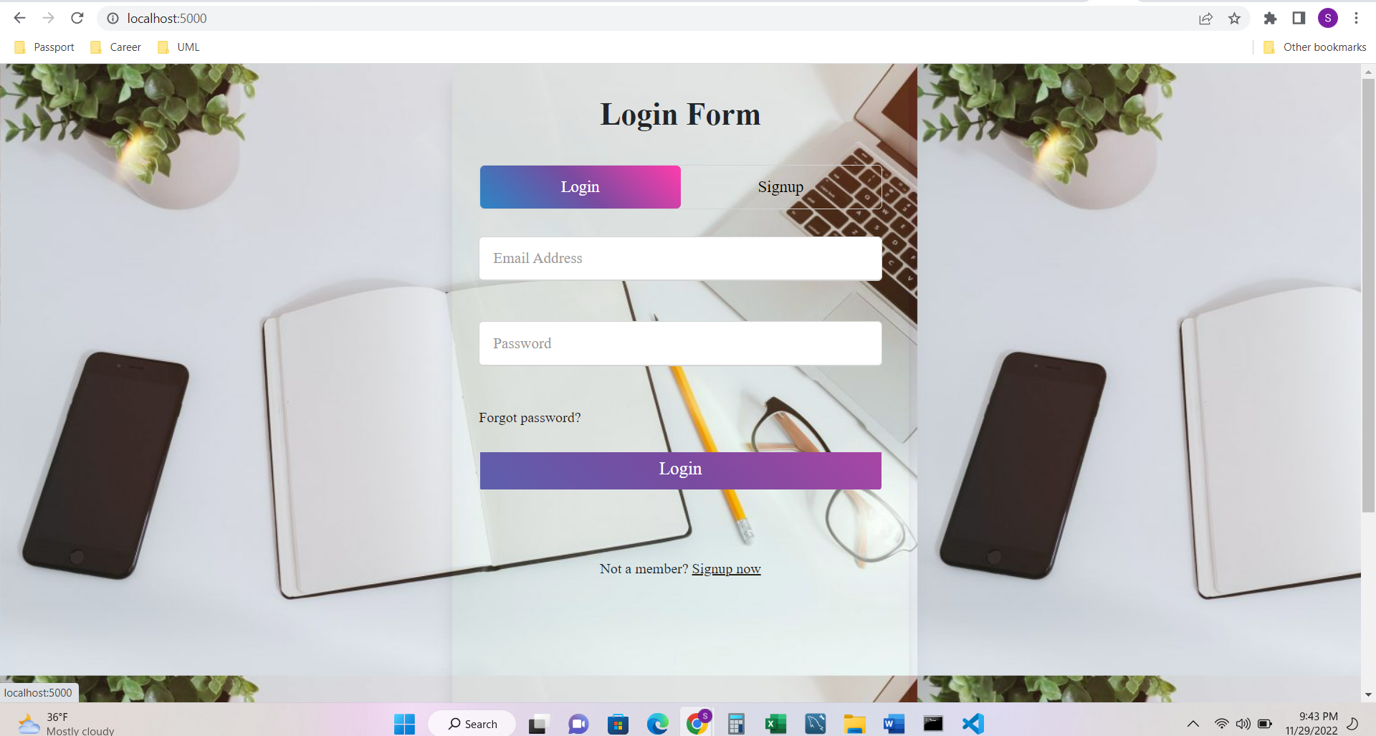

**Sign-Up Form**

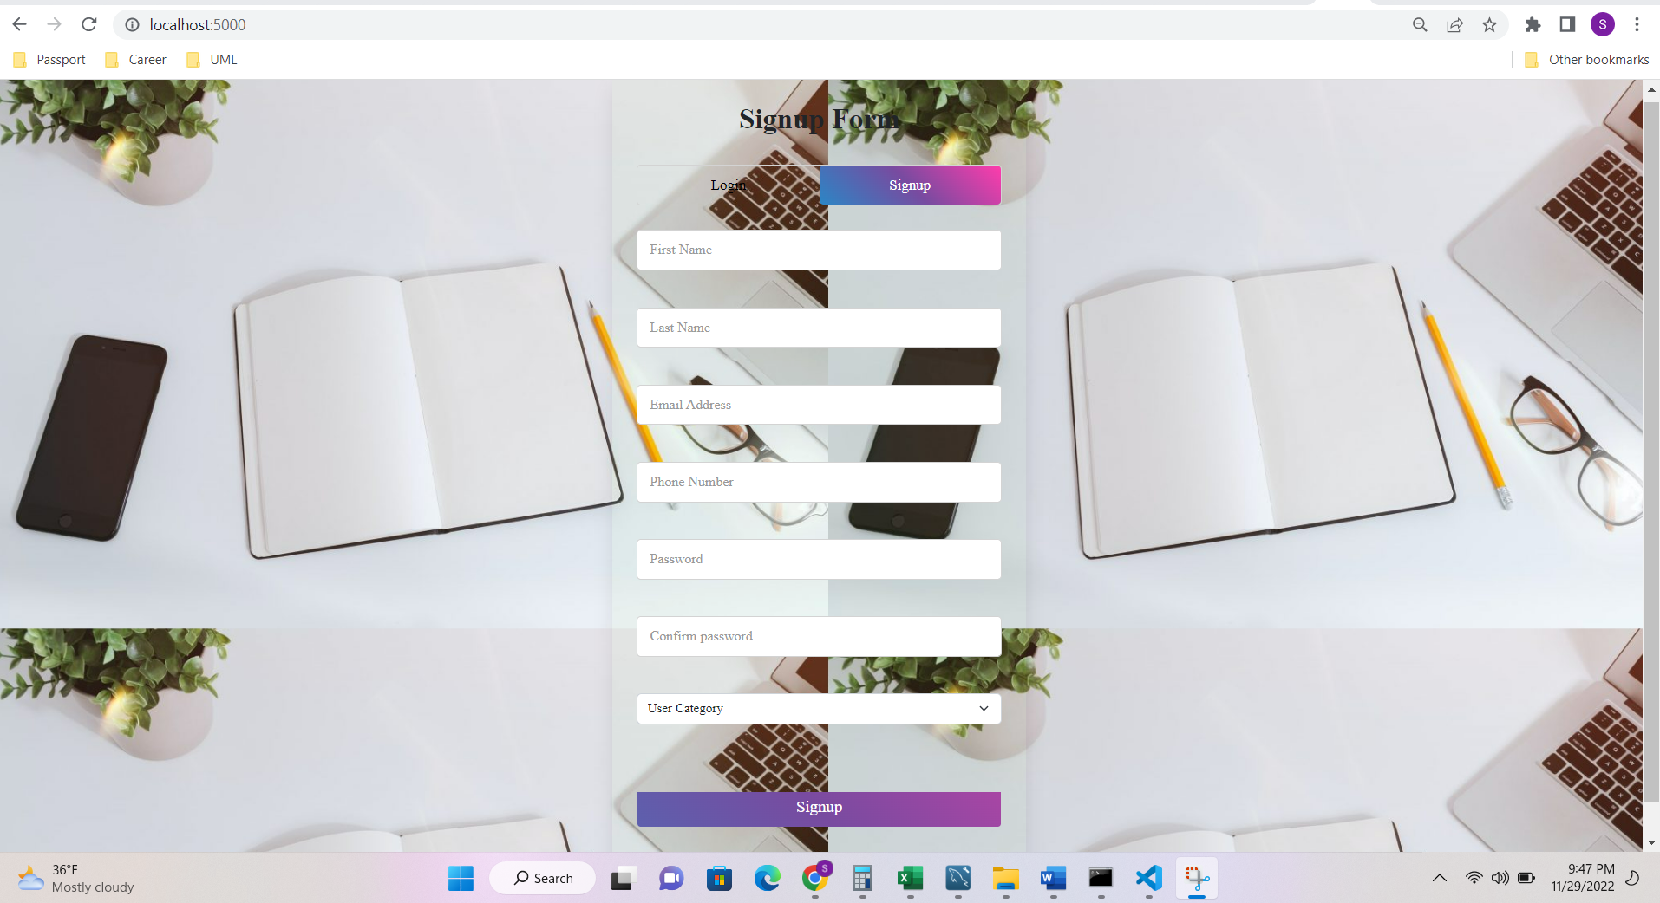

**After Sign-Up, Login with the credentials**

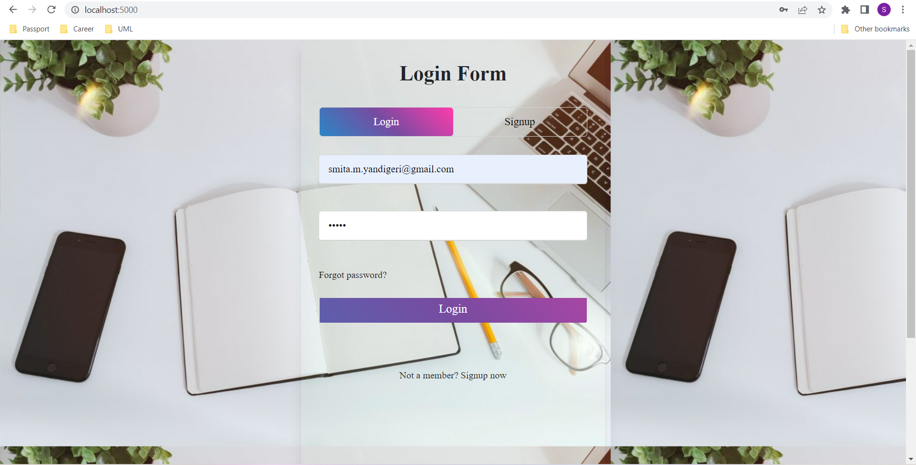

**After teacher logs in, the teacher can add her Class with Class name, Class Code, Invitation code is auto generated. There are edit class and delete class buttons and View HomeWorks.**

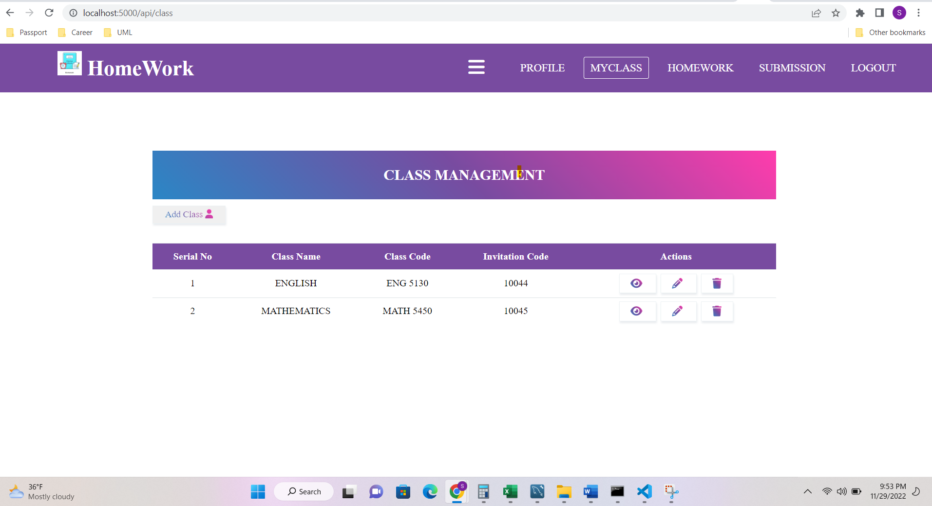

**On adding the Mathematics Class, Teacher can add the HomeWorks for that’s class.**

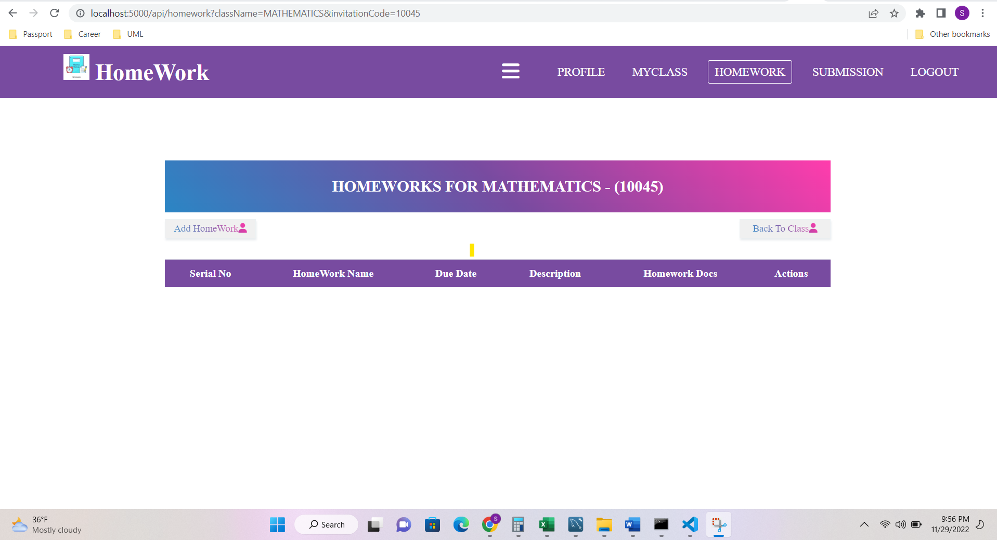

**Add Homework**

**After Adding Homework, we can edit the homework and delete the homework**

**Student Portal to View classes**

**Student Portal to View homework and Upload homework**

**Notification of newly added homework**

